
SIMULATION AND MODELING
(CY378)
PROJECT REPORT
AGENT-BASED SIMULATION AND REDESIGN OF THE TERBREBIE JUNCTION ROAD NETWORK
A Traffic and Pedestrian Flow Improvement Study Using AnyLogic

Lecturer: Frank Laude Boateng
Project File: TerbrebieJunction3.alp (AnyLogic)
Date of Submission: 27th July 2026

Submitted by: Group Members Listed Below

No. | Name | Index Number | Role
1 | ADU PAUL | FCM.41.018.014.23 | Group Leader
2 | BOATENG YAW OPOKU | FCM.41.018.107.23 | Member
3 | FELIX AGYIRE | FCM.41.018.023.23 | Member
4 | DONKOR ZIPPORAH | FCM.41.018.126.23 | Group Leader
5 | ENOCH ODURO | FCM.41.018.197.23 | Member
6 | JOSEPH EDUAFO | FCM.41.018.128.23 | Member
7 | NAKOREI ABDULAI SHAFIYU | FCM.41.018.180.23 | Member
8 | MENSAH-ONUMAH JONATHAN JNR. | FCM.41.018.174.23 | Member
9 | COFFIE OBED KAKARI | FCM.41.018.115.23 | Member
10 | DICK BISMARK KOJO | FCM.41.018.123.23 | Member
11 | NOUTERAH MAXWELL FAGBOM | FCM.41.018.187.23 | Member
12 | BINEY JUSTICE | FCM.41.018.097.23 | Member
13 | AMOO SAMUEL NII DODOO OBREMPONG | FCM.41.018.052.23 | Member
14 | ADELAIDE NTRIWAA BOAKYE | FCM.41.018.100.23 | Member

Table of Contents
1. Introduction and Background of the Study Area 4
2. Problem Statement: Condition of the Existing Road 5
2.1 Photographic Evidence of the Original Junction (Before Changes) 5
3. Objectives of the Project 8
4. Methodology and Tools Used 9
5. Description of the Proposed Changes and Justification 10
5.1 Introduction of Double Lanes 10
5.2 Installation of Traffic Lights 10
5.3 Introduction of Zebra Crossings and Pedestrian Infrastructure 11
5.4 Resurfacing and General Road Improvement 11
6. Model Architecture and Component Description 12
6.1 Model Verification 13
6.2 Model Validation 13
7. Simulation Layout and Visual Output 14
8. Expected Outcomes and Benefits 16
9. Challenges and Limitations 16
10. Economic Implications 17
1. Capital & Operational Expenditure (Infrastructure Costs) 17
2. Travel Time & Congestion Savings 17
3. Accident Cost Reduction 17
4. Economic Development & Land-Use Secondary Effects 18
5. Summary Assessment & Recommendation 18
Conclusion and Recommendations 19

1. Introduction and Background of the Study Area
Terbrebie Junction is a busy road intersection that serves as a key connecting point between a main arterial road and a secondary access road within its locality. The junction is bordered by a mix of residential houses, small shops, and commercial buildings, and it is used daily by a significant volume of vehicles, including private cars, commercial vehicles, and heavy trucks, as well as pedestrians who live in and move through the surrounding neighbourhood. Because of this mixed use, the junction experiences a steady flow of both motorised and non-motorised traffic throughout the day, with visible peaks during the morning and evening commuting periods.
This report documents the work carried out by the group as part of the Simulation and Modeling (CY378) course, in which the existing layout of Terbrebie Junction was studied, modelled, and subsequently redesigned using AnyLogic simulation software. The purpose of the exercise was to apply agent-based and road traffic modelling concepts learnt in class to a real-world junction, identify the operational weaknesses of its current design, and propose and simulate practical improvements that would enhance safety and efficiency for all road users.

2. Problem Statement: Condition of the Existing Road
Prior to the changes proposed in this project, Terbrebie Junction operated with a very basic and, in several respects, inadequate road layout. Specifically, the following deficiencies were identified on the original road:
- The road in every direction leading into the junction consisted of only a single lane, meaning that vehicles travelling in the same direction had no option to overtake slower-moving traffic, and any obstruction, breakdown, or turning vehicle caused the entire approach to back up.
- There was no traffic light or any other form of formal signal control at the junction, so right of way was determined informally by drivers, which frequently led to congestion, confusion, and near-miss incidents at the point of conflict between crossing traffic streams.
- No zebra crossings or designated pedestrian crossing points existed at the junction, despite the presence of residential areas and foot traffic on both sides of the road, forcing pedestrians to cross wherever they judged it safe, often in the direct path of moving vehicles.
- The road surface itself was in a poor state of repair, with uneven paving that further slowed traffic and made the junction less safe and less comfortable for both drivers and pedestrians.
Collectively, these conditions made Terbrebie Junction inefficient and hazardous, motivating the group to use simulation modelling to test and validate a redesigned layout before any such change would be recommended for real-world implementation.

2.1 Photographic Evidence of the Original Junction (Before Changes)
The images below were captured prior to the redesign and confirm the deficiencies described in Section 2. They show the junction operating as a single-lane approach in every direction, with no traffic light, no marked pedestrian crossing, and no dedicated turning lane, consistent with the problems identified by the group at the outset of the project.
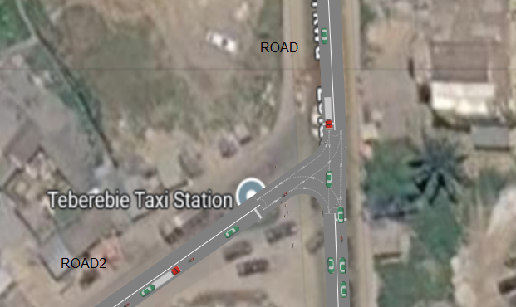

Figure 4: Aerial view of the original Terbrebie Junction, showing a single-lane approach in every direction with no traffic light or marked pedestrian crossing.

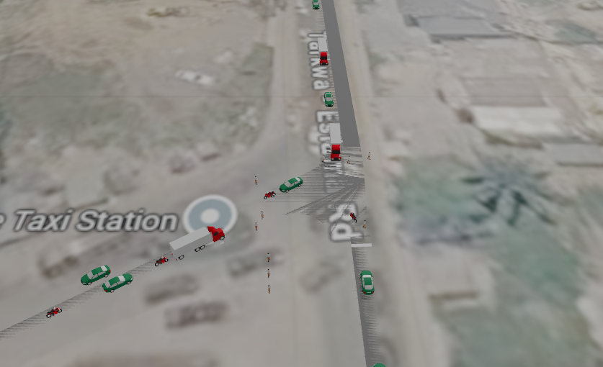

Figure 5: Close-up aerial view of the original junction, confirming the absence of lane markings, signal control, and pedestrian infrastructure.
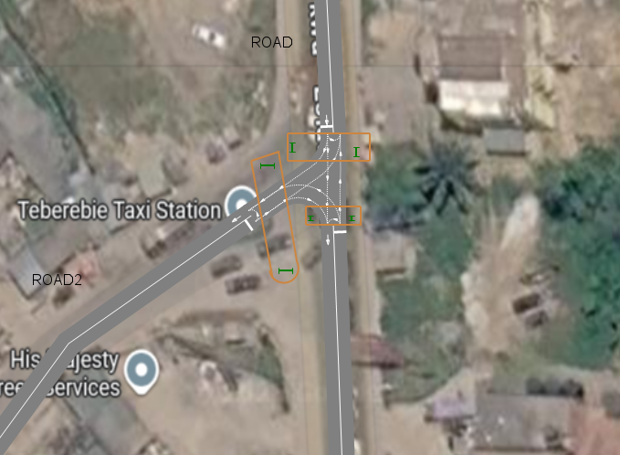
Figure 6: Site analysis of the original junction, showing the locations identified by the group for the introduction of traffic lights and pedestrian crossings in the redesign.

3. Objectives of the Project
The specific objectives pursued by the group in this project were as follows:
- To recreate the existing single-lane, unsignalised layout of Terbrebie Junction as a baseline model within AnyLogic.
- To design and implement an improved road layout featuring dual lanes in each direction, signalised control through traffic lights, and marked pedestrian crossings.
- To model the movement and interaction of both vehicles and pedestrians through the junction under the new layout, using AnyLogic's Road Traffic and Pedestrian Library components.
- To evaluate, through simulation, whether the proposed changes would be expected to reduce congestion, improve traffic flow, and improve pedestrian safety at the junction.
- To present findings and recommendations in a report suitable for academic submission and for informing possible real-world road authority action.

4. Methodology and Tools Used
The group used AnyLogic, a multi-method simulation software package, to construct the model of Terbrebie Junction. AnyLogic was selected because it provides purpose-built libraries for both road traffic simulation and pedestrian dynamics, allowing vehicles and pedestrians to be modelled as individual agents that interact with lanes, intersections, traffic lights, and crossing points in a realistic manner.
The model, saved as the project file TerbrebieJunction3.alp, was constructed using the Road Traffic Library for all car-related agents and infrastructure, and the Pedestrian Library for all pedestrian-related agents and infrastructure. Vehicle generation, routing, and disposal were modelled using carSource, selectOutput, carMoveTo, and carDispose blocks, while pedestrian generation, movement, waiting, and disposal were modelled using pedSource, pedGoTo, pedWait, and pedSink blocks. Traffic light objects were placed at the junction to coordinate the right of way between competing vehicle and pedestrian flows. The full breakdown of these components and their function is presented in Section 6.
The physical road environment, including lane markings, buildings, trees, and surrounding structures, was laid out on a 2D and 3D scene to closely resemble the real junction, after which the model was run to observe vehicle and pedestrian behaviour under the new configuration.

5. Description of the Proposed Changes and Justification
The redesign implemented in this project directly addresses each of the deficiencies identified in the original road layout. Each change is explained and justified below.

5.1 Introduction of Double Lanes
The single lane available in each direction on the old road was replaced with double lanes in the new design. This change was included for the following reasons:
- Additional lane capacity allows a greater number of vehicles to be processed by the junction within the same period of time, directly reducing queue lengths and congestion during peak periods.
- With two lanes available, slower vehicles, such as heavy trucks turning or loading, no longer block the entire flow of traffic, since following vehicles can move into the adjacent lane to continue their journey.
- Separate lanes make it possible to assign specific movements, such as through-traffic and turning traffic, to different lanes, which reduces conflict points and makes traffic behaviour more predictable and easier to control at the junction.
- Double lanes provide a buffer of space that improves overall road safety, since vehicles have more room to manoeuvre and react to unexpected situations, such as a pedestrian stepping into the road or a vehicle stopping suddenly.

5.2 Installation of Traffic Lights
The new design introduces traffic lights at the junction, where none previously existed. The justification for this addition is as follows:
- Traffic lights formally assign right of way to each approach in turn, removing the ambiguity and informal negotiation between drivers that previously caused delays and near-collisions at the junction.
- Signal control allows the timing of vehicle movement to be coordinated with pedestrian crossing phases, so that vehicles and pedestrians are never granted conflicting rights of way at the same time.
- A signalised junction can be tuned, through the timing of its phases, to match the actual demand on each approach, which allows the flow of traffic to be optimised rather than left to chance.
- Traffic lights create a consistent and predictable pattern of stopping and moving, which in turn reduces the likelihood of sudden braking, side collisions, and the kind of gridlock that was common on the original unsignalised junction.

5.3 Introduction of Zebra Crossings and Pedestrian Infrastructure
Marked zebra crossings and pedestrian pathways have been introduced at points where residents and other pedestrians are known to cross the road. The reasons for this addition include the following:
- A designated crossing point gives pedestrians a clearly marked and predictable place to cross, rather than crossing at random points along the road as was previously the case.
- When paired with the pedestrian phase of the traffic light, a zebra crossing ensures that pedestrians are given a protected interval in which to cross safely, without competing directly with moving traffic.
- Formal pedestrian infrastructure acknowledges the residential character of the area surrounding the junction and reflects the group's finding that a meaningful volume of foot traffic uses the junction daily.
- Reducing informal and unpredictable pedestrian crossing behaviour is expected to lower the risk of pedestrian-related accidents, which was identified as a significant safety concern under the old layout.

5.4 Resurfacing and General Road Improvement
In addition to the lane and signal changes, the new design assumes a better paved and properly marked road surface, in place of the deteriorated surface on the old road. A well-maintained and clearly marked road surface improves vehicle traction and control, makes lane discipline easier for drivers to follow, and generally supports safer and more efficient use of the additional lanes and signal infrastructure described above.

6. Model Architecture and Component Description
The AnyLogic model represents the junction as a network of vehicle and pedestrian flows, each constructed from a standard set of building blocks. Multiple car sources and pedestrian sources were used, one for each approach or path into the junction, so that the model realistically reflects traffic and foot movement arriving from every direction. The table below summarises the principal components used in the model and the role each one plays.
Component | Function in the Model
carSource / carSource1-4 | Vehicle generators that inject cars into each arm of the junction according to a defined arrival rate, representing traffic approaching from the four directions of the road network.
selectOutput | Decision blocks that route each vehicle onto the correct lane or path (through, left turn, or right turn) based on the probability or logic assigned to the new double-lane configuration.
carMoveTo | Movement blocks that carry vehicles along a defined path or lane segment at a realistic speed, used to model the additional lanes introduced in the redesign.
carDispose | Exit blocks that remove vehicles from the simulation once they have cleared the junction, marking the end of a vehicle's journey through the model.
trafficLight / trafficLight1-2 | Signal control objects that regulate the right of way at the junction, alternating between red and green phases to manage conflicting vehicle and pedestrian movements.
pedSource / pedSource1-4 | Pedestrian generators that introduce pedestrians into the model at defined points along the junction, representing residents and commuters using the area.
pedGoTo | Pedestrian movement blocks that guide pedestrians along footpaths and across the new zebra crossings toward their destination.
pedWait | Blocks that hold pedestrians at the kerb or crossing point until the pedestrian phase of the traffic light grants them right of way, enforcing safe crossing behaviour.
pedSink | Exit blocks that remove pedestrians from the simulation once they have completed their crossing or walking path.

Vehicles are generated at each carSource and, where an approach offers a choice of movement, are routed by a selectOutput block onto the appropriate carMoveTo path before being removed from the model at a carDispose block once they clear the junction. The same logical pattern is followed for pedestrians, who are generated at a pedSource, walk along a pedGoTo path, pause at a pedWait block until the crossing phase permits movement, and are removed at a pedSink once they reach their destination. Traffic lights are linked to both the vehicle paths and the pedestrian crossing points, ensuring that the two flows are coordinated rather than left to interact freely, which was the central weakness of the original junction.

6.1 Model Verification
Verification was carried out to confirm that the AnyLogic model was built correctly and behaves as intended, independently of whether it accurately represents the real junction. The following verification checks were performed by the group:
- The model was run in step-by-step and reduced-speed modes so that vehicle and pedestrian agents could be visually traced through each block (carSource, selectOutput, carMoveTo, carDispose, pedSource, pedGoTo, pedWait, pedSink) to confirm that they followed the intended logical path.
- The process flow diagram (Figure 1) was cross-checked, block by block, against the actual AnyLogic model to confirm that every connection matched the intended design.
- Multiple simulation runs were observed to confirm that every vehicle and pedestrian generated at a source was eventually removed at its corresponding dispose or sink block, with no agents becoming stuck or disappearing unexpectedly.
- The selectOutput blocks were checked to confirm that routing probabilities directed vehicles onto the correct lanes in the proportions intended by the group.
- The timing of each traffic light phase was checked against its programmed values to confirm that the signal behaved as configured, and that conflicting vehicle and pedestrian phases were never active at the same time.

6.2 Model Validation
Validation was carried out to confirm that the model, once verified as correctly built, also provides a reasonable and credible representation of the real Terbrebie Junction and of how the proposed redesign would be expected to behave. The following validation approaches were used:
- Face validation: the 2D and 3D layouts produced in AnyLogic (Figures 2 and 3) were compared side by side with the satellite imagery and photographs of the real junction (Figures 4 to 6) to confirm that the geometry, road alignment, and surrounding landmarks such as the Teberebie Taxi Station were represented with reasonable accuracy.
- Group members familiar with the junction reviewed the simulated traffic and pedestrian behaviour and confirmed that it reflected the general pattern of congestion and pedestrian movement observed
- Extreme condition testing was performed by setting vehicle arrival rates to unusually low and unusually high values; the model responded logically in both cases, producing free-flowing traffic at low demand and visible queuing at high demand, consistent with real traffic behaviour. • Sensitivity checks were carried out by adjusting the traffic light phase durations and observing that queue lengths and waiting times changed in the expected direction, confirming that the model responds sensibly to changes in its input parameters.
- Since the redesign had not yet been implemented at the time of this study, validation of the improvement claims remains partial. The group recommends that, once implemented, real traffic data be collected and compared against the model's output as a further validation step, as noted in Section 9.

7. Simulation Layout and Visual Output
The following figures show the model as constructed in AnyLogic. Figure 1 presents the process flow diagram of the model, showing how car and pedestrian agents are generated, routed, and disposed of. Figure 2 presents the 2D layout of the redesigned junction, showing the double lanes, the positions of the traffic lights, and the marked pedestrian crossings. Figure 3 presents the 3D animated view of the same junction, illustrating how vehicles and pedestrians are expected to move through the improved layout during a simulation run.

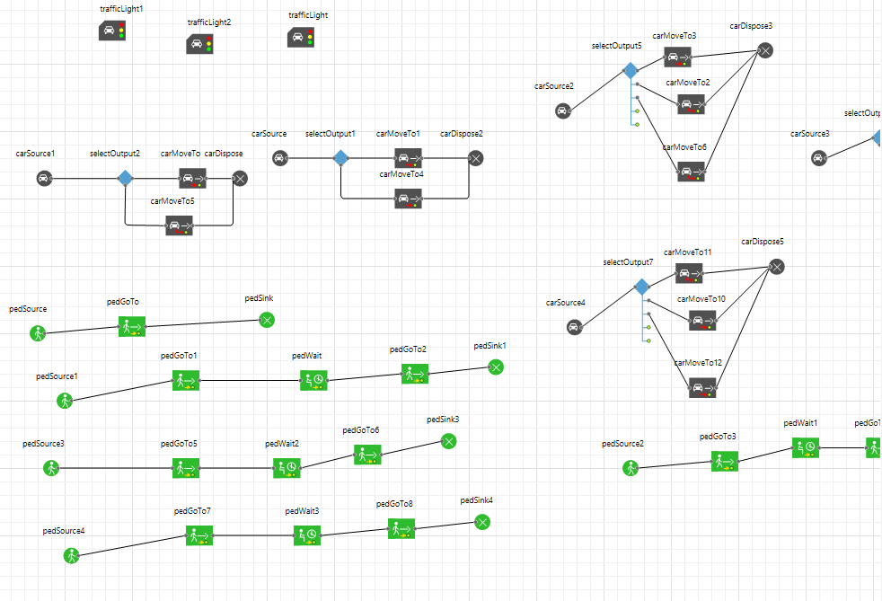
Figure 1: Process flow diagram of vehicle and pedestrian agents in the AnyLogic model.
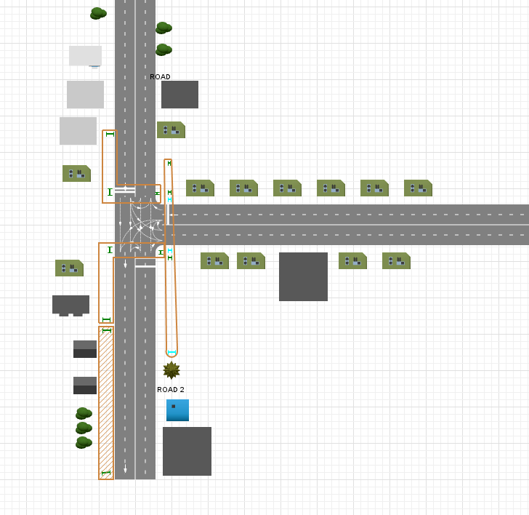
Figure 2: 2D layout of the redesigned Terbrebie Junction, showing double lanes, traffic lights, and pedestrian crossings.
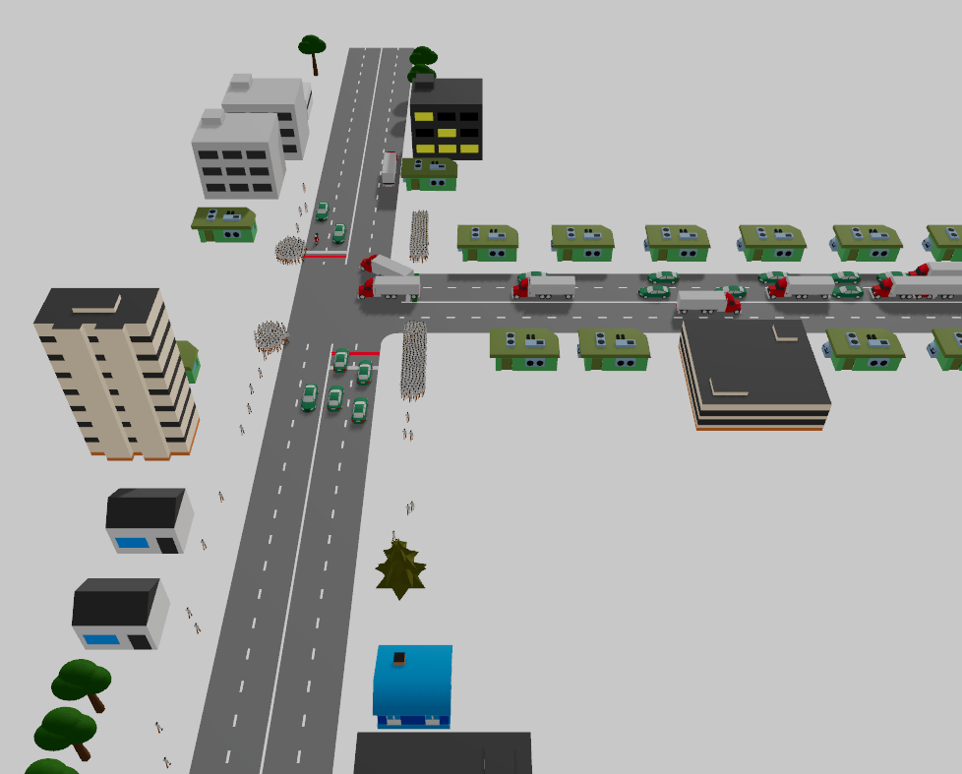
Figure 3: 3D animated view of the redesigned junction during a simulation run, showing vehicle and pedestrian flow.

8. Expected Outcomes and Benefits
Based on the design changes implemented and simulated, the group anticipates the following outcomes if the redesign were to be adopted at the real Terbrebie Junction:
- A reduction in vehicle queuing and congestion at the junction, resulting from the additional lane capacity and the ability to separate through and turning traffic.
- A more orderly and predictable flow of traffic, resulting from the introduction of signal control in place of informal right of way negotiation.
- Improved safety for pedestrians, resulting from the provision of marked crossings that are coordinated with the traffic light phases.
- An overall improvement in the driving and walking experience at the junction, supported by better road surfacing and clearer lane markings.

9. Challenges and Limitations
The group encountered a number of challenges while carrying out this project.
Accurately estimating realistic arrival rates and traffic volumes for each approach without access to formal traffic count data required the group to make reasonable assumptions based on observation.
Coordinating the timing of the traffic lights with pedestrian crossing phases also required careful adjustment to avoid unrealistic waiting times for either vehicles or pedestrians.
In addition, replicating the exact physical geometry of the junction within the simulation environment, including building placement and road curvature, was time-consuming and involved several rounds of refinement.
These limitations do not undermine the core findings of the project but are noted here for completeness and to guide any future refinement of the model.

10. Economic Implications
While the project's primary scope is academic, any road infrastructure redesign carries real-world economic consequences. The proposed redesign balances upfront civil works costs against long-term operational savings, safety gains, and regional development.

1. Capital & Operational Expenditure (Infrastructure Costs)
Upfront capital costs must be met by local government or road authorities, but these costs are typical amortized over a 15 to 20-year design life, keeping annual costs modest relative to overall construction figures:
- Lane Widening & Resurfacing: Expanding from single to double lanes requires civil works (excavation, sub-base preparation, asphalt, kerb installation) alongside repaving degraded surfaces.
- Traffic Signals: Procurement and setup of two signalised traffic light units (poles, controller hardware, cabling, power) represent a one-off capital investment.
- Pedestrian Infrastructure: Paint for zebra crossings, kerb ramps, and refuge islands (comparatively low cost).
- Recurring Maintenance: Ongoing maintenance and periodic replacement of signal hardware and road markings.

2. Travel Time & Congestion Savings
The most immediate and directly quantifiable benefit is the reduction in vehicle delay:
- Reduced Fuel Consumption: Shorter queues and reduced idling directly decrease fuel expenditure for commuters and commercial transport.
- Commuter Productivity: Aggregated time savings across daily peak-hour commutes yield direct macroeconomic value.
- Freight & Supply Chain Efficiency: Faster travel times and predictable journeys lower operating costs for commercial vehicles and heavy trucks in the area.
- Regional Precedent: Similar urban junction upgrades in sub-Saharan Africa demonstrate a 30% to 50% reduction in average peak-period vehicle delay.

3. Accident Cost Reduction
Road accidents impose high monetary costs on households, emergency services, healthcare facilities, and insurance systems. Safety is improved through three mechanisms:
- Signalised control eliminates informal right-of-way negotiation (reducing side-impact collisions).
- Dedicated pedestrian light phases remove hazardous interactions with vehicles.
- Double lanes with resurfaced pavement improve driver sight lines and reduce sudden braking (preventing rear-end collisions).
- Direct Economic Value Saved: Reduces emergency response deployment, hospitalization/medical expenses, vehicle repair costs, insurance payouts, and legal/administrative fees.

4. Economic Development & Land-Use Secondary Effects
Terbrebie Junction serves adjacent residential areas, small shops, commercial entities, and key regional hubs (such as the University of Mines and Technology in Tarkwa):
- Local Business Footfall: Reduced congestion and safer walking access boost customer visits to nearby small businesses and informal traders.
- Property Value Uplift: Improved safety and accessibility enhance rental and real estate values surrounding the junction.
- Investor Confidence: Infrastructure upgrades signal government investment, stimulating secondary residential and commercial developments.
- Regional Connectivity: Smooth flow along key transit corridors creates positive economic multiplier effects beyond the immediate neighborhood.

5. Summary Assessment & Recommendation
- Cost-Benefit Ratio: The qualitative analysis indicates that economic returns - primarily driven by accident avoidance and aggregate fuel and time savings - will significantly exceed initial capital costs.
- Prerequisite Action: The study strongly recommends that relevant road authorities conduct a formal, quantitative Cost-Benefit Analysis (CBA) using measured traffic counts and updated construction cost data before committing to implementation.

Conclusion and Recommendations
This project has demonstrated, through simulation, that the deficiencies of the original Terbrebie Junction layout, namely single-lane approaches, the absence of traffic light control, and the absence of pedestrian crossings, can be addressed through a redesigned layout incorporating double lanes, signalised control, and marked pedestrian crossings, supported by improved road surfacing. The AnyLogic model constructed by the group provides a working demonstration of how such a junction would be expected to operate under the proposed changes, and it may serve as a foundation for further, more detailed traffic engineering analysis.
The group recommends that the relevant road authority consider the findings of this study when planning future improvement works at Terbrebie Junction, and further recommends that, prior to implementation, real traffic count data be collected to refine the arrival rates and signal timings used in the model, so as to maximise the benefit of the proposed redesign to both drivers and pedestrians in the area.

